Mechanical Overview

Year: 2019 Semester: Fall Team: 19 Project: Digitopoly

Creation Date: 9/20/2019 Last Modified: 9/20/2019

Author: Alex Gokan Email: agokan@purdue.edu

Assignment Evaluation:

|  |  |  |  |  |
| --- | --- | --- | --- | --- |
| **Item** | **Score (0-5)** | **Weight** | **Points** | **Notes** |
| **Assignment-Specific Items** | | | | |
| **Commercial Packaging Analysis 1** | 5 | x2 | 10 |  |
| **Commercial Packaging Analysis 2** | 5 | x2 | 10 |  |
| **CAD Model Illustrations** | 5 | x4 | 20 |  |
| **Project Packaging Specifications** | 5 | x2 | 10 |  |
| **PCB Footprint Layout** | 5 | x2 | 10 |  |
| **Writing-Specific Items** | | | | |
| **Spelling and Grammar** | 5 | x2 | 10 |  |
| **Formatting and Citations** | 5 | x1 | 5 |  |
| **Figures and Graphs** | 5 | x2 | 10 |  |
| **Technical Writing Style** | 5 | x3 | 15 |  |
| **Total Score** | 100 | | |  |

5: Excellent 4: Good 3: Acceptable 2: Poor 1: Very Poor 0: Not attempted

Comments:

*Great work on the report! Well done!*

1. Commercial Product Packaging
   1. Product #1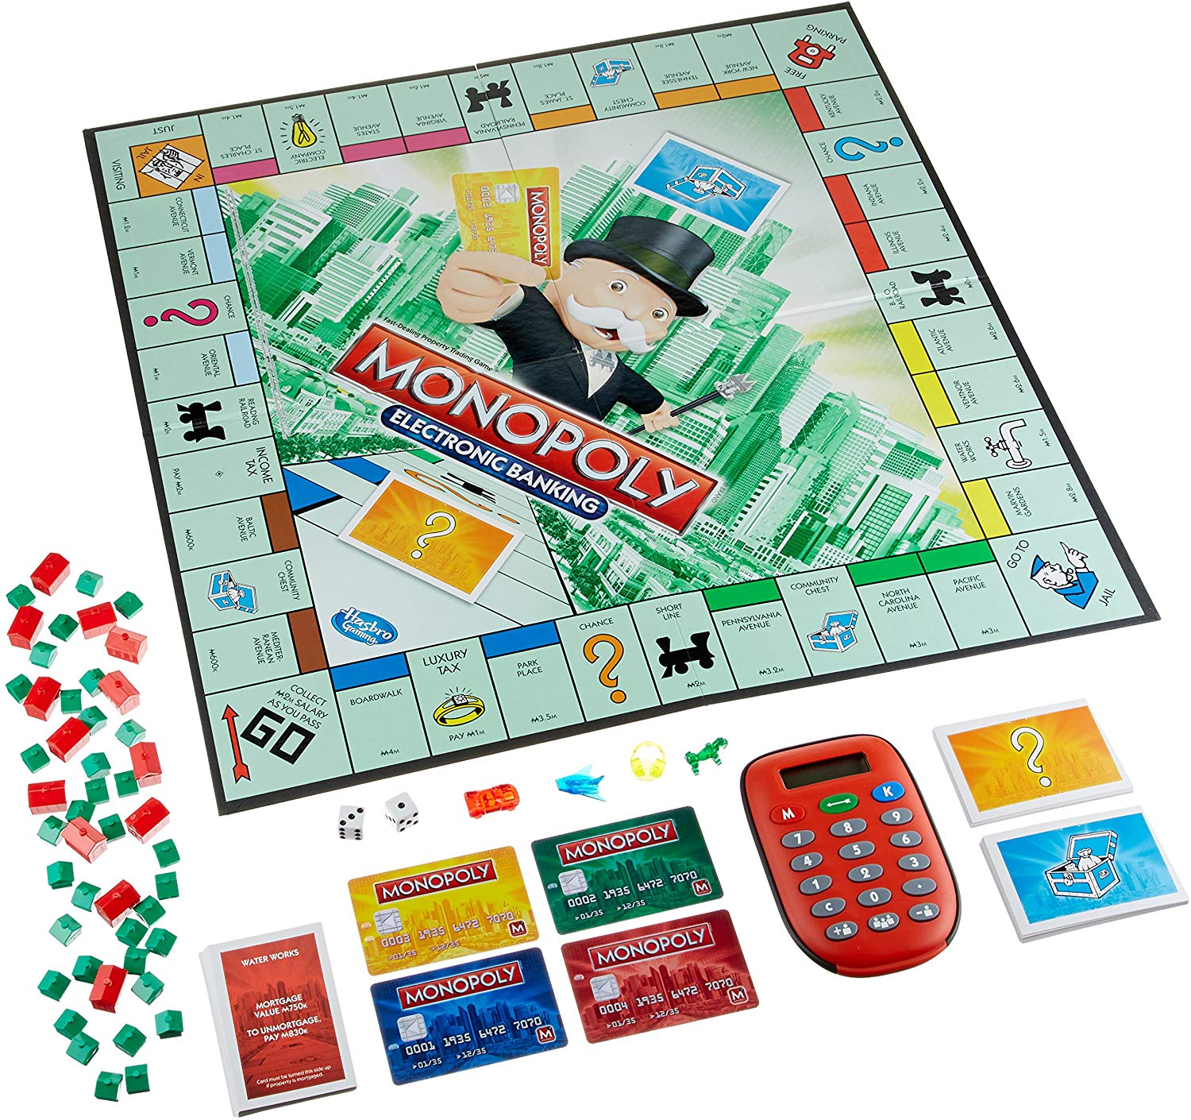

The first commercial product similar to Digitopoly is the original that we based our project off of - electronic Monopoly. Although this physical board version is drastically different from the purely electronic one we are developing, we wanted to retain the original features of the game in our project, which was to have the original Monopoly board, physical game pieces and physical dice.

In this new version, players would use ‘credit cards’ to store their funds instead of holding the game’s paper cash [1]. The card could be modified using a banking device which could be used to add or remove money from the card, and by extension the player’s account. Since that would still have been a bit more complicated, we decided to move all banking functions into the software, and have users fully aware of the funds in their account by showing it on the screen.

The product’s packaging was quite dense with materials like instruction manuals, the cards, the actual board, the banking device, and numerous little pieces that could get lost easily. In our product we would not have too many loose pieces - just the four player pieces and two dice. That would minimize the chance of lost pieces, and make our product more appealing to use.

* 1. PlayTable

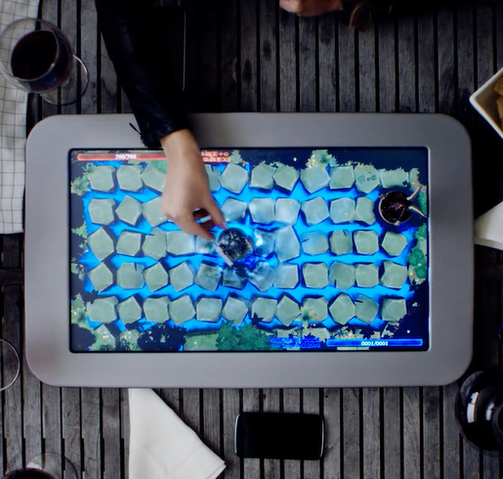

This is the PlayTable, the world’s first tabletop gaming console. We primarily looked at this product because of the very modern and sleek packaging, particularly around the screen. The PlayTable perfectly melded together the physical pieces of old board games with the vibrant display.

The reduced mechanical requirements of the PlayTable (it has no capability to physically move the pieces) mean it can be in a significantly thinner package than what we can make with our own product [2]. As a result our product would be a bit thicker due to its increased mechanical complexity.

We really liked the look of the frame around the screen, so we will try to replicate that in our product. We would definitely look into using other materials other than what was used in the PlayTable, to reduce potential damage by bumps or short drops, and to improve upon the look of our product overall.

3.0 Sources Cited

[1] Amazon: Monopoly Electronic Banking Game. [Online]. Available: <https://www.amazon.com/Hasbro-A7444-Monopoly-Electronic-Banking/dp/B00EDBZ9F8>

[2] Playtable: The World’s First Tabletop Gaming Console [Online]. Available:

[https://www.playtable.com](https://www.playtable.com/)

Appendix 1: CAD Model Illustrations

Overall Dimensions:

|  |  |
| --- | --- |
| Length | 654 mm |
| Width | 605 mm |
| Height | 116 mm |

Dice Dimensions:

|  |  |
| --- | --- |
| Length | 32 mm |
| Width | 32 mm |
| Height | 32 mm |

Fig. 1: Enclosure without top acrylic plate, dimensions in millimeters

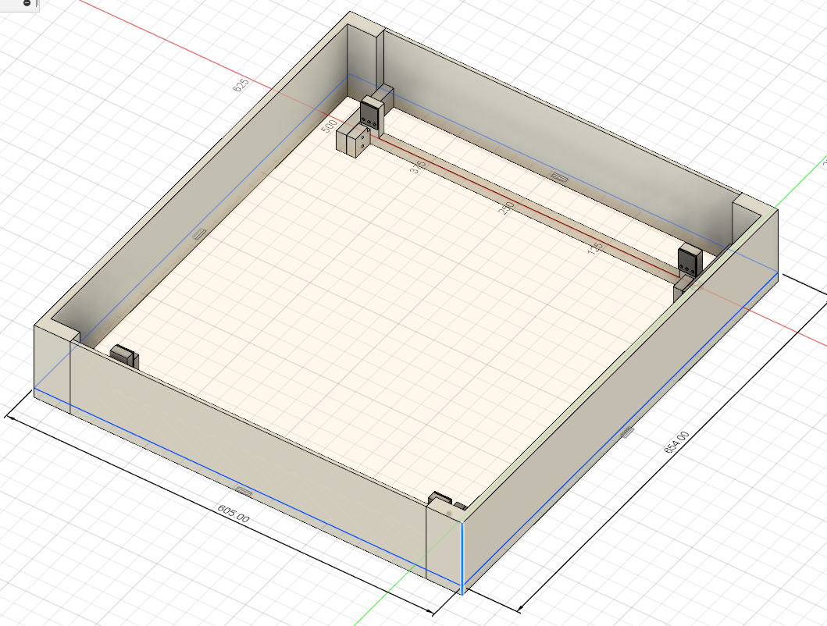

Fig 2: Close-up of mounting point for plotter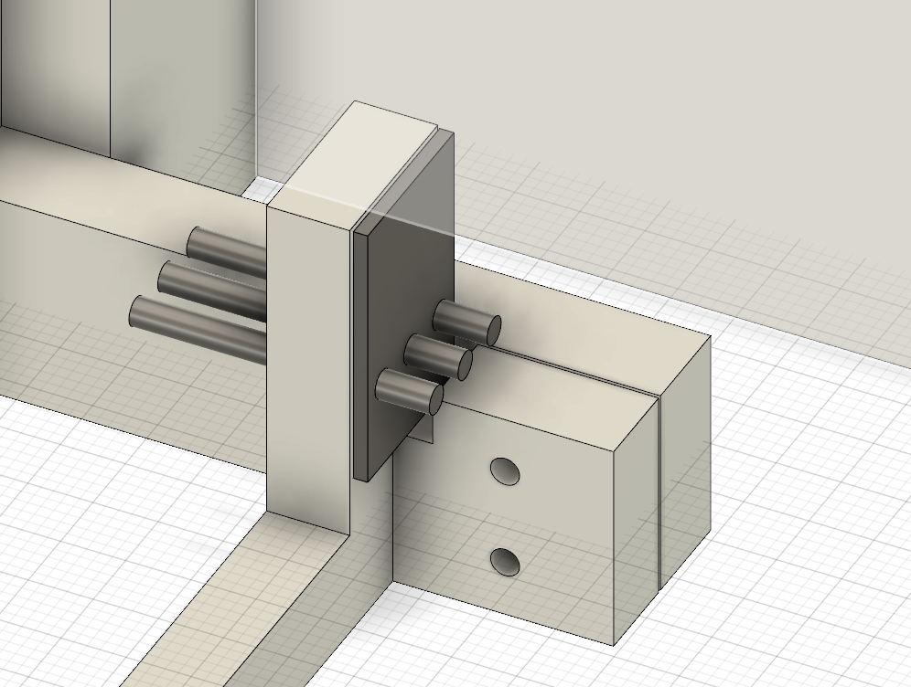

Fig 3: Mounting bracket with dimensions (millimeters)

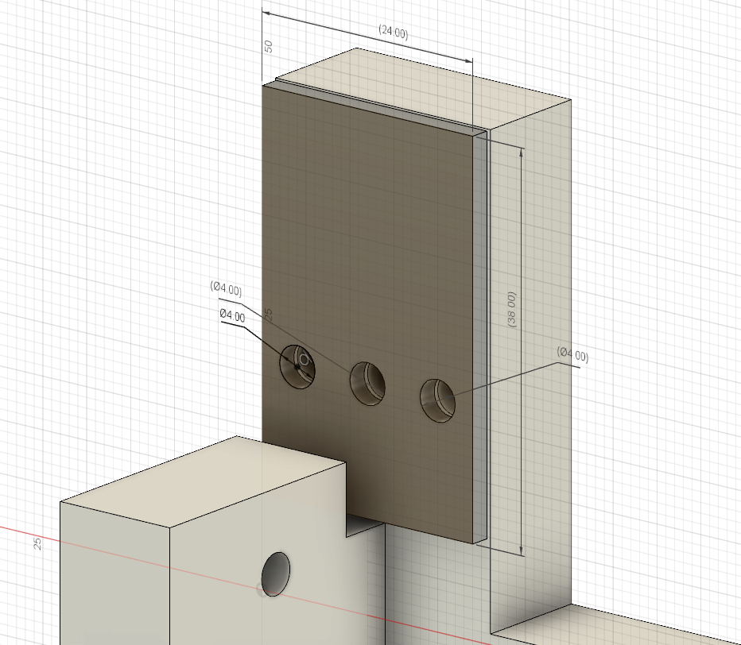

Fig 4: Original display sitting inside of enclosure

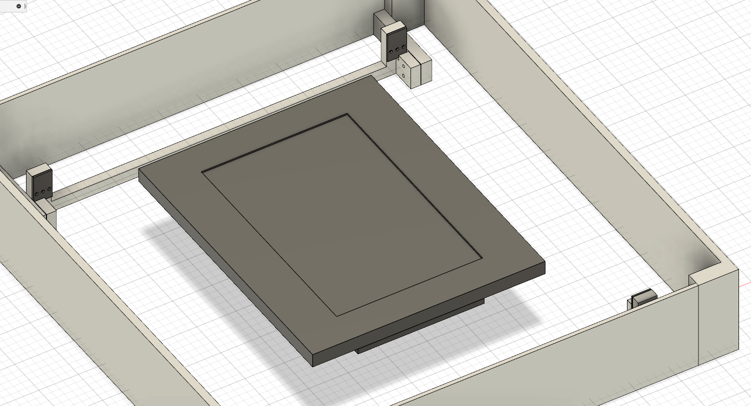

Fig 5: Enclosure with acrylic sheet on top

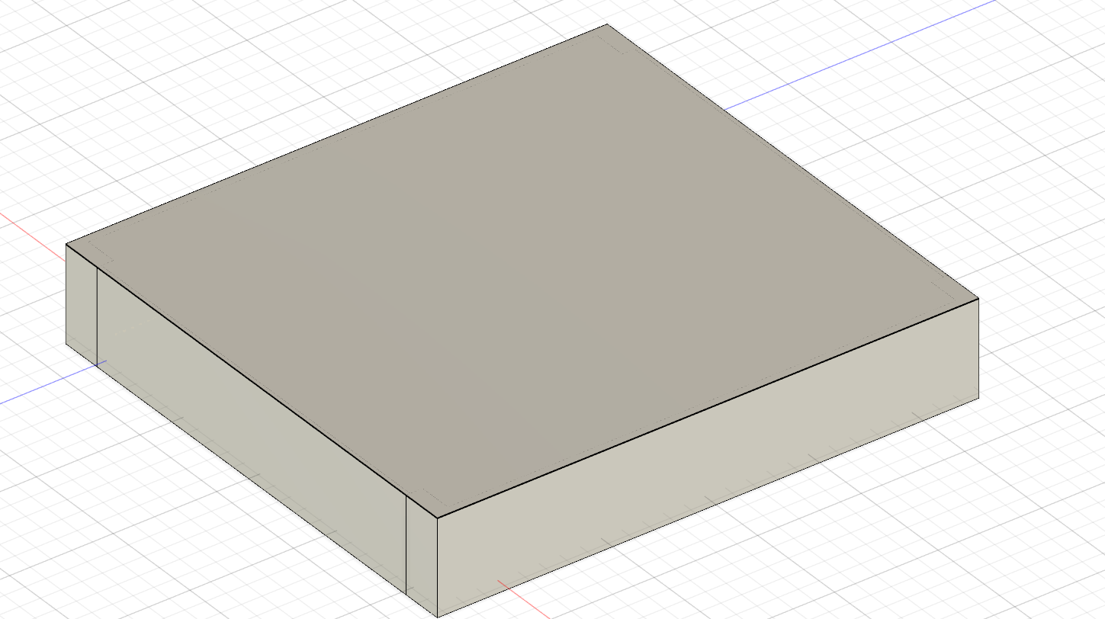

Fig 6: Dice

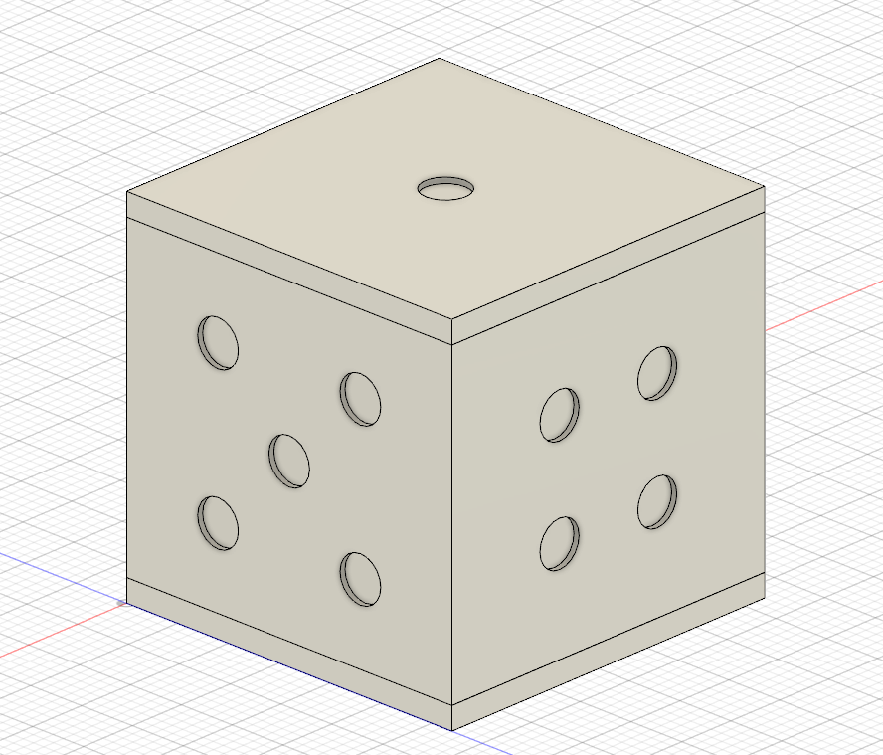

Fig 7: Top/bottom dice plate (dimensions in mm)

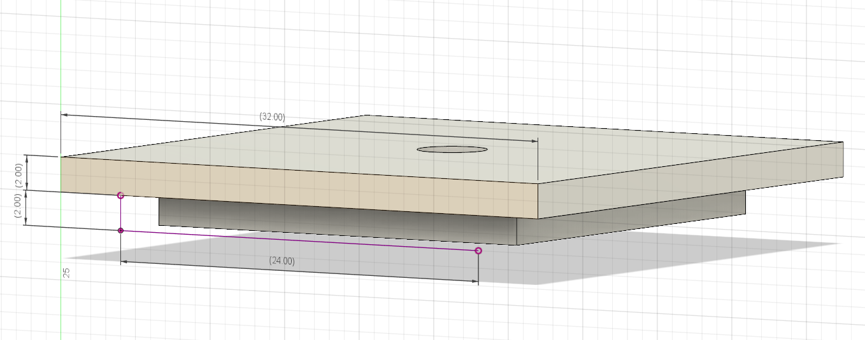

Fig 8: Center body of dice (dimensions in mm)

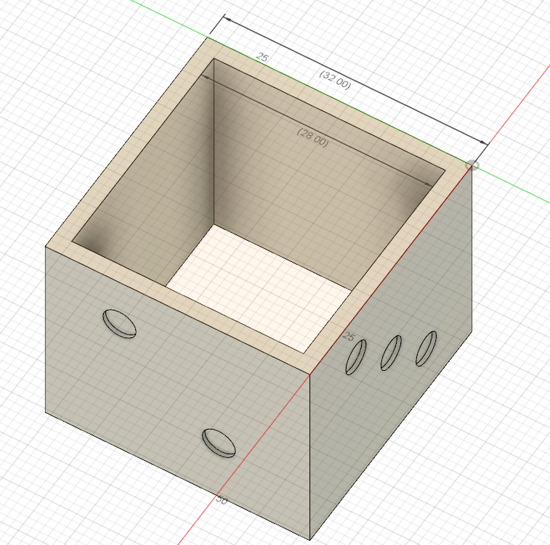

**Appendix 2: Project Packaging Specifications**

Materials list:

|  |  |  |  |  |  |
| --- | --- | --- | --- | --- | --- |
| Material | Quantity | Unit cost | Total Cost | Manufacturer | Source |
| ABS filament | 3.5 kg | $25/spool (1.75 kg) | $50 | Octave | Amazon.com |
| Acrylic plate | 1 plate (605 x 654 mm) | $33.71/plate (711 x 762 mm) | $33.71 | AmeriLux | Menards |
| Bolts (4 mm) | 16 | $0.25/bolt | $4 | Everbilt | Home Depot |
| Nuts (4 mm) | 16 | $0.34/nut | $5.44 | Not listed | Home Depot |
| **Total Cost** |  |  | **$93.15** |  |  |

Weight: unless otherwise noted, these weights are estimated using ABS plastic

|  |  |  |  |  |  |
| --- | --- | --- | --- | --- | --- |
| Part name | unit weight (100% infill) | unit weight (30% infill) | quantity | total weight (upper bound - 100% infill) | total weight (lower bound - 30% infill) |
| dice body | 7 g | 2 g | 1 | 7 g | 2 g |
| dice end caps | 3.5 g | 1 g | 2 | 7 g | 2 g |
| mounting plates | 137 g | 41 g | 2 | 274 g | 82 g |
| back plates | 393 g | 118 g | 2 | 786 g | 236 g |
| side plates | 997 g | 299 g | 2 | 1994 g | 598 g |
| top plate (acrylic) | 470 g | | 1 | 470 g | |
| bolts | 23 g | | 16 | 368 g | |
| nuts | 2.25 g | | 16 | 36 g | |
| **Total Weight** |  |  |  | **3943 g** | **1794 g** |

Tooling requirements:

|  |  |
| --- | --- |
| Tooling | Cost |
| 3D Printing | Free (3D printer owned by project member) |
| Laser Cutting (acrylic) | Free (at BIDC) |

Appendix 3: PCB Footprint Layout

Fig 1: Main game board PCB footprint

The maximum height of this pCB is 20mm because of the height of the Raspberry Pi 4 (13 mm tall + 7mm standoffs/overhead). This is the only area with possible clearance issues.

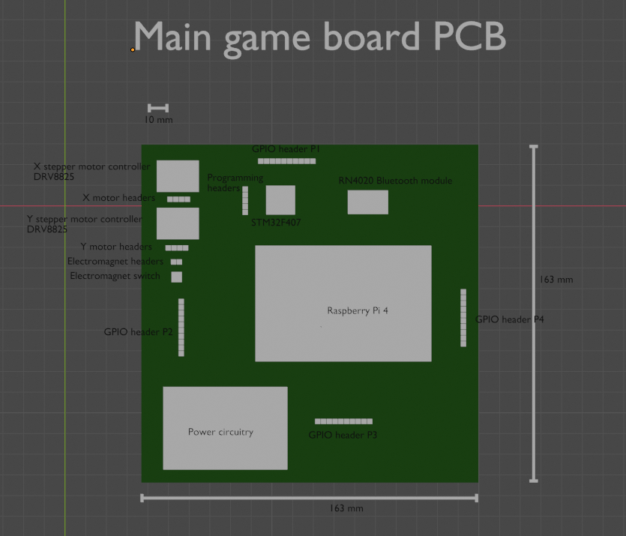

Fig 2: Dice PCB footprint

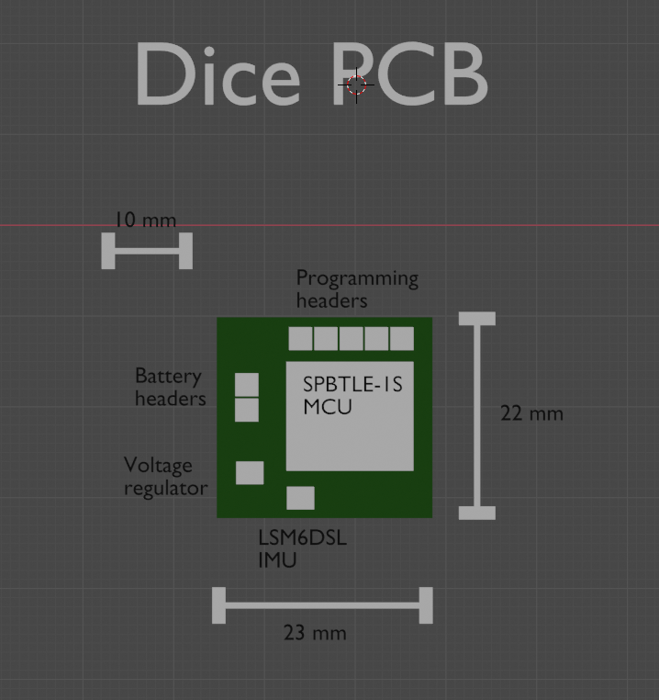

Fig 3: Dice wireless charging PCB footprint

